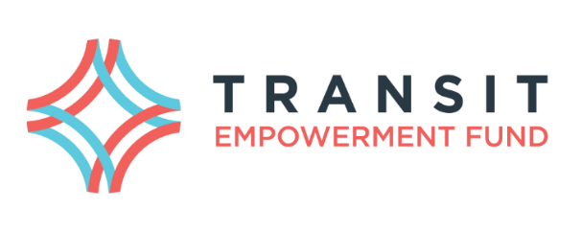

MICROGRANT APPLICATION

About the Transit Empowerment Fund | The Transit Empowerment Fund (TEF) was established in 2011 as a partnership between Capital Metro and One Voice Central Texas to enhance access to transportation. An independent Board oversees the work of the Fund including the distribution of transit passes to nonprofit organizations and support of demonstration projects. The Board includes representatives from the nonprofit and business communities and Capital Metro
Purpose of Microgrants | Microgrants are designed to provide additional opportunities to meet the TEF mission of enhancing access to transportation for low-income, transit-dependent individuals in the Austin area. All microgrants must focus on transportation for low-income (200% of poverty guidelines or below) individuals.
Eligibility | Only 501(c)3 organizations or governmental entities are eligible to apply
Maximum grant award | $1,000 in bus passes or in a lump sum grant. Passes will be purchased at the non-profit rate of 50% of face value and so should be calculated that way. Fares can be found at: http://www.capmetro.org/fares/
Frequency of Awards | Microgrants will be reviewed on a quarterly basis: January, April, July, and October.
Deadline for application | Applications must be received at least five working days prior to the quarterly Board meeting at which applications will be reviewed. The TEF Board meets on the fourth Tuesday of each month.
Reporting | Following a successful application, the applicant will be required to provide a brief report that describes how the microgrant was used and the number of people impacted.
Submission | All applications must be submitted electronically to sam@successfulgiving.com . Call 512-217-6862 with any questions
APPLICATION | To apply answer the following
Name & Address of Organization
Contact Person
Contact Phone and Email
Organization’s Mission
Describe how this microgrant will support the mission of TEF and assist individuals to access education, employment, healthcare, or social services? (Max 2,000 characters with spaces)
How many individuals will be impacted?
Who will be targeted?
If this is for an event, what is the date, time, location, and purpose of the event?
If this funding is going to be used as match or leverage for another grant, please let us know.
Any additional information you would like to provide?

